Literacy support worksheet

4.1 The properties of matter can be described

Pages 62–63 and 178

Properties of matter

1 What is matter?

2 To be called matter, a substance must have two things. List them below and explain what they are measured in.

a

b

Part 1 – Solids, liquids and gases

3 Are the substances in the following images solids, liquids or gases or a mixture?

|  |  |  |  |  |
| --- | --- | --- | --- | --- |
| SW0301_01361-r | SW0302_01361-r | SW0303_01361-r | SW0304_01361-r | SW0305_01361-r |
|  |  |  |  |  |

|  |  |  |  |  |
| --- | --- | --- | --- | --- |
| SW0306_01361-r | SW0307_01361-r | SW0308_01361-r | SW0309_01361-rf | SW0310_01361-r |
|  |  |  |  |  |

Part 2 – Chemical and physical properties

4 What are some examples of what might happen during a chemical reaction?

a

b

c

5 What is a physical property of matter?

6 What are the physical properties of the following substances?

a 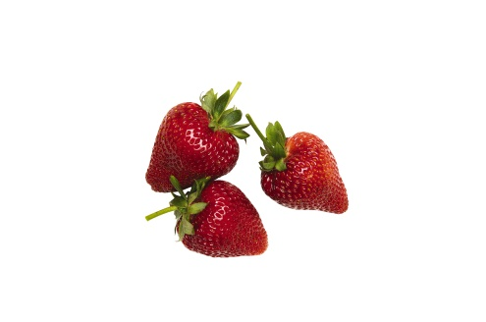

Colour:

Texture:

b 

Colour:

Texture:

Shape:

Word detective

7 Quick quiz

Circle whether the following situations show physical properties (P) or chemical properties (C).

a Water boils at 100ᵒC C or P

b Diamond is used to cut glass. C or P

c Salt is able to dissolve in water. C or P

d Paper is flammable. C or P

e Magnesium metal will burn to form a white powder. C or P

f Nitrogen is a gas at room temperature. C or P

g A ball of aluminium will sink faster in water than a piece of aluminium foil. C or P

h If your car is left in the rain, the Iron will form rust. C or P

i A sheet of aluminium is battered with a hammer until flat. C or P

j Vapour pours out of the freezer as you get out the ice cream. C or P

k The cling wrap melts over the plate of food in the microwave. C or P

l A cake burns in the oven. C or P

Literacy support worksheet

4.2 Scientists understanding of matter has developed over the years

Pages 64–65

An introduction to particle theory

Part 1 – Scientists’ contribution to particle theory

1 Scientific theory involves at least three steps. What are they?

a

b

c

2 What does the word ‘atomos’ mean?

3 Name two things that modern chemistry was able to discover about particle theory that Dalton and Democritus were not.

Part 2 – How do particles behave in solids, liquids and gases?

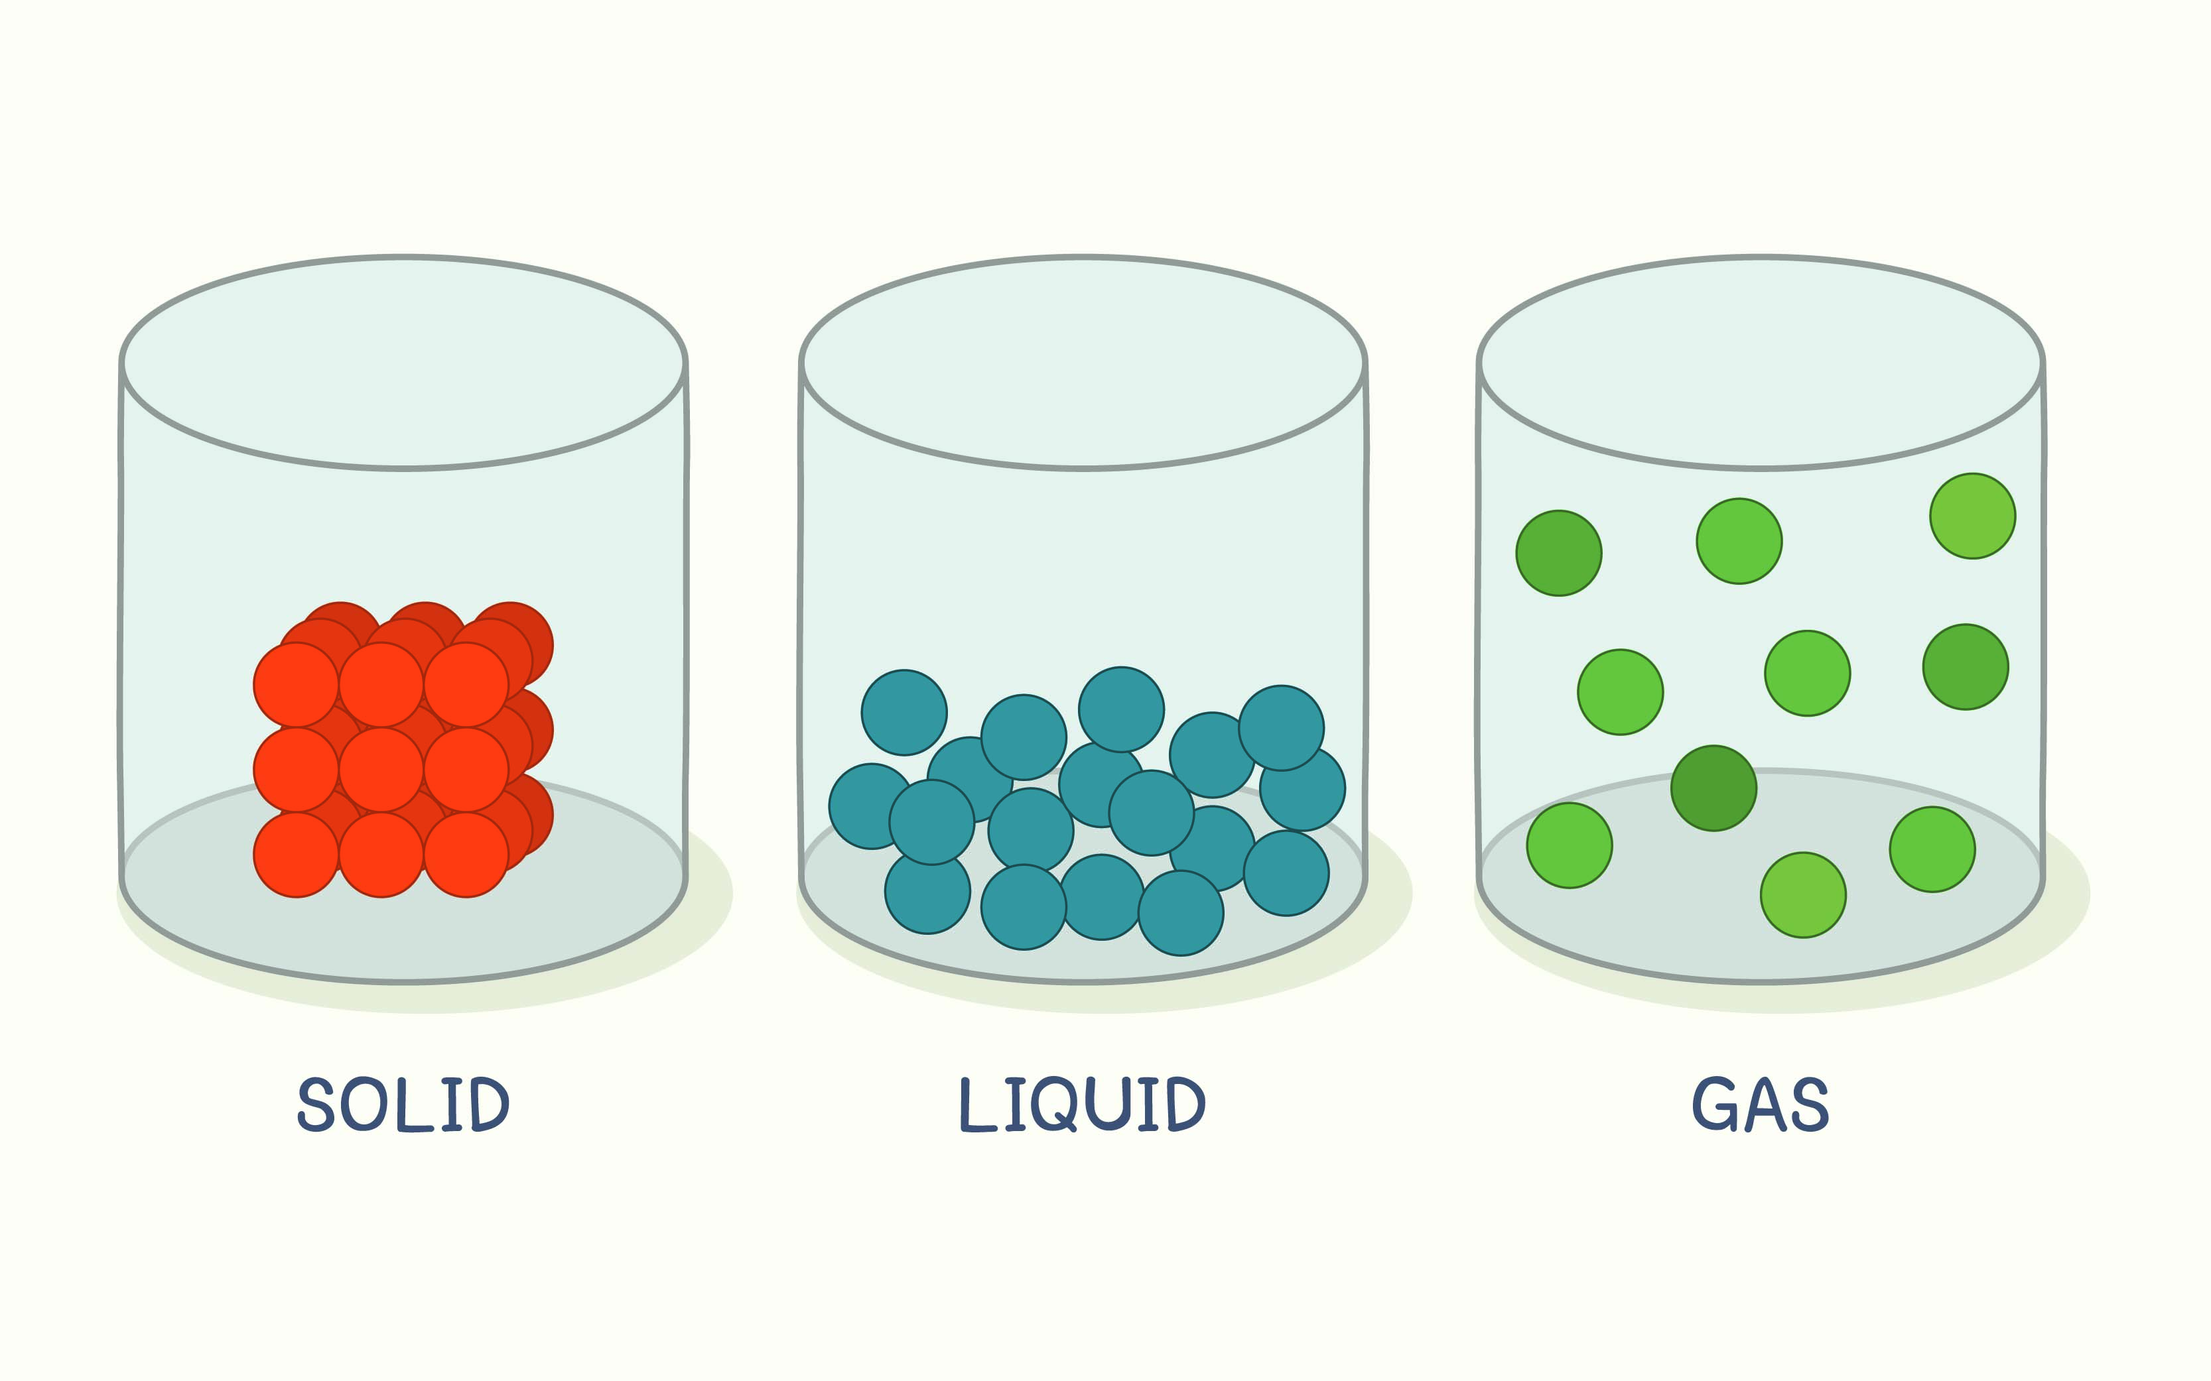

4 States of matter differ in several ways. Using the diagram above and the information on p 65 in *Oxford Science 8*, answer the questions below.

Am I a solid, liquid or gas? My particles:

a are very closely packed together:

b move over one another without moving away from each other:

c will fill an entire container:

5 Using Figure 4.6 in Oxford Science 8, finish the sentences below.

Each molecule contains:

A molecule is made up of:

6 Look around the room and find three things that are solids, two things that are liquids and at least one gas.

Three solids:

Two liquids:

A gas

Word detective

7 Draw and label

Draw and label the particles found in a solid, a liquid and a gas. Use the diagrams on p 65 of *Oxford Science 8* to help you. Use the following phrases in your labels:

Particles bound closely together

Particles moving around each other more freely

Particles moving quickly and separate from each other

Literacy support worksheet

4.3 The particle model explains matter

Pages 66–67 and 179

Using the particle model to explain matter

Part 1 – Kinetic theory of matter

1 The pictures below have been compared to states of matter. Name the state of matter (solid, liquid or gas) and explain how the things in the images compare to that state in their structure and the way that they move. Use the information on p 66 of Oxford Science 8 to help you. The first one has been done for you.

|  |  |  |
| --- | --- | --- |
| Eggs in a carton | L:\1. Publishing and Editorial\1. Product\Oxford Science\Oxford Science 8\3. Extras\8. Student worksheets\Artwork\jpgs ready for worksheets\SW0414_00951.jpg | State of matter: Solid  Structure: There is a fixed structure.  Movement: There is no movement of the eggs and there is no kinetic energy. |
| Balls in a ball pit | L:\1. Publishing and Editorial\1. Product\Oxford Science\Oxford Science 8\3. Extras\8. Student worksheets\Artwork\jpgs ready for worksheets\SW0415_00951.jpg | State of matter:    Structure:    Movement: |
| A school of fish swimming in all directions | L:\1. Publishing and Editorial\1. Product\Oxford Science\Oxford Science 8\3. Extras\8. Student worksheets\Artwork\jpgs ready for worksheets\SW0417_00951-r.jpg | State of matter:    Structure:    Movement: |
| A wall built out of Lego blocks | L:\1. Publishing and Editorial\1. Product\Oxford Science\Oxford Science 8\3. Extras\8. Student worksheets\Artwork\jpgs ready for worksheets\SW0418_00951-r.jpg | State of matter:    Structure:    Movement: |
| Dandelion fluff forming aircrafts in the sky | L:\1. Publishing and Editorial\1. Product\Oxford Science\Oxford Science 8\3. Extras\8. Student worksheets\Artwork\jpgs ready for worksheets\SW0416_00951.jpg | State of matter:    Structure:    Movement: |

Part 2 – Diffusion

2 Give an example of diffusion.

3 Give an example of diffusion in a liquid.

4 Why does diffusion occur the fastest in gases?

5 If you spay air freshener on one side of the room, you can typically smell it in a very short space of time.

 

Explain why this is.

6 Refer to the pictures in Q5. If a liquid diffuser was used instead of a spray, would it take you more or less time to smell the fragrance?

7 The following diagram represents a tea bag in a hot cup of water. In the glasses provided, demonstrate what happens to the tea as it diffuses through the water.

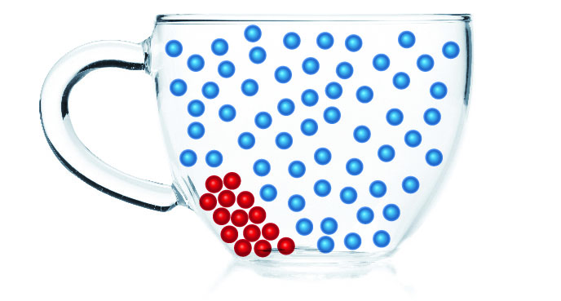→ 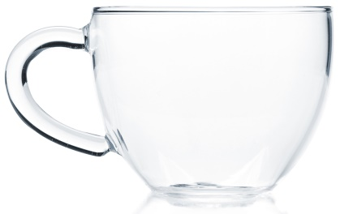 → 

Word detective

8 Secret message

Use words from *Oxford Science 8* to fill in the puzzle below. Then, use your answer to complete the sentence below.

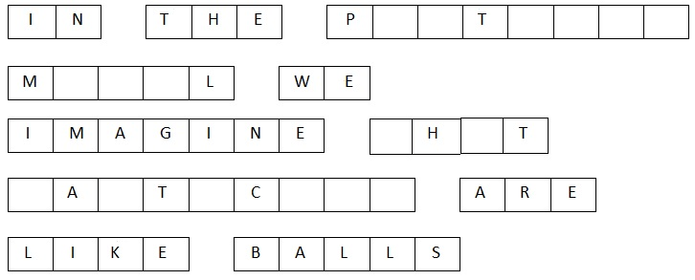

In the p \_\_\_\_\_\_\_\_\_\_\_\_\_\_\_\_\_\_\_ m \_\_\_\_\_\_\_\_\_\_\_\_\_\_\_\_\_\_\_ of matter, the \_\_\_\_\_\_\_\_\_\_\_\_\_\_\_\_\_\_\_s

are always moving.

Literacy support worksheet

4.4 The particle model can explain the properties of matter

Pages 68–69 and 180

Using the particle model to explain properties of matter

Part 1 – Strength

1 What is tensile strength?

2 Circle whether wire or a rubber band has greater tensile strength. Explain why.

 

3 Compressional strength is the ability to withstand large forces without being crushed. Circle whether a piece of rock candy or a marshmallow would have greater compressional strength.Explain why.

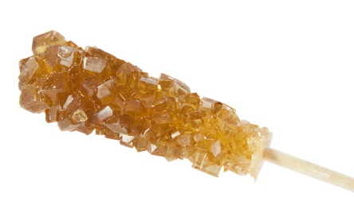 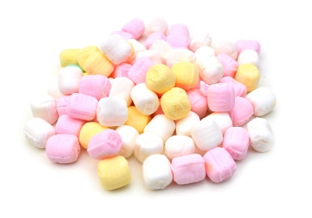

Part 2 – Hardness

4 Explain what hardness is.

5 Circle the substance that would be more brittle. Explain why.

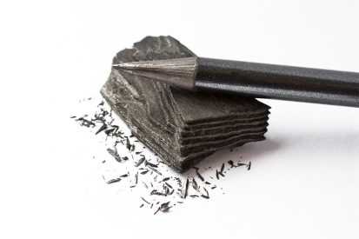 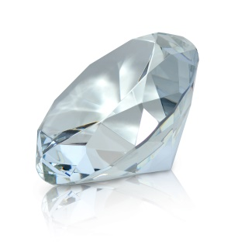

Part 3 – Viscosity

6 Which substance would have a greater viscosity? Explain why.

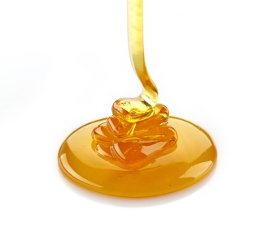vs 

Part 4 – Compressibility

7 Using your knowledge of the particle model of matter, explain why it is possible to compress a gas.

(Refer to Figure 4.16 of *Oxford Science 8* to help you).

8 Why is it that solids or liquids cannot be compressed? (Refer to Figure 4.8 of *Oxford Science 8* to help you).

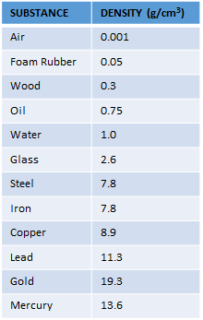Part 5 – Density

9 Cork is made of wood and it is less dense than water. Use the table to complete the following:



a The density of wood is \_\_\_\_\_\_\_\_\_\_\_\_\_\_ and the density of water is

\_\_\_\_\_\_\_\_\_\_\_\_\_\_\_\_\_.

b The material listed with the highest density is \_\_\_\_\_\_\_\_\_\_\_\_\_\_\_\_\_.

10 Why does the cork float in water?

Word detective

11 Mumbo jumbo

a Use the marked letters to find the secret word (e.g. olusntoi = solution).

b Unscramble each of the clue words below to find the message.

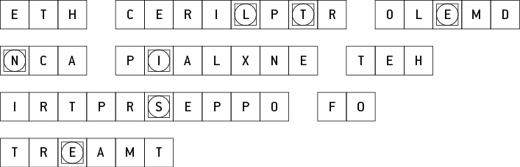

Secret word:

Message:

Literacy support worksheet

4.5 Increasing kinetic energy in matter causes it to expand

Pages 70–71 and 182–184

Heating particles and expansion

Part 1 – Heating particles

1 In the circles, draw what the particles look like as liquids or gases (solid has been done for you). On the black lines, write whether there is an increase or decrease in energy and an increase or decrease in heat (the first one has been done for you).



**Increase energy and heat**

**Solid**

**Liquid**

**Gas**

2 When a solid changes to a liquid:

a what happens to the movement of particles?

b Why does particle movement change?

3 When a liquid changes to a gas, why does particle movement change?

4 For each change in state, give an example from your daily life.

a Solid to liquid:

b Liquid to gas:

c Solid to gas:

d Gas to liquid:

e Liquid to solid:

f Gas to solid:

Part 2 – Heat causes expansion

5 Finish the end of this sentence: When you put a thermometer in your mouth, it causes the liquid to:

6 When you cannot open the lid of a jar of spaghetti sauce, you might run the lid under a hot tap to open it. Why might this work?

7 Sometimes on a hot day, you may not be able to get a ring on your finger that normally fits. Why not?

Word detective

8 Crossword

Read the clues below and fill in the crossword with the answers.

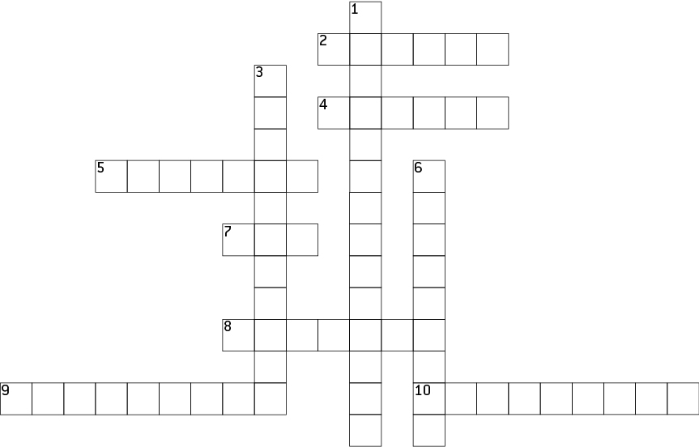

**Across**

2 To expand means to increase in size or \_\_\_\_\_\_\_\_\_\_\_\_\_.

4 When a gas condenses it reaches this state

5 When the particles move harder, faster and wider they \_\_\_\_\_\_\_\_\_\_\_.

7 Particles move about freely in this state

8 This type of energy makes particles move faster

9 Occurs faster in hot water and involves particles spreading out.

10 Heat causes \_\_\_\_\_\_\_\_\_\_\_\_\_\_\_ or the spreading out of a material.

**Down**

1 Occurs when a substance cools and becomes solid

3 The opposite of expansion.

6 When you heat matter, you are passing on heat energy to the \_\_\_\_\_\_\_\_\_\_\_.

Literacy support worksheet

4.6 Atoms and elements make up matter

Pages 72–73 and 185-187

Atoms, elements and the periodic table

1 Match the statements to the correct elements by drawing a line between them.

|  |  |  |
| --- | --- | --- |
| Element |  | Statement |
| SW0332_01361 |  | 1 I am a group 2 element and am the reason fireworks are bright red. I am element number 38. |
| SW0333_01361 |  | 2 I am a transition metal … and the title of a famous song. I am number 22 on the periodic table. |
| SW0334_01361 |  | 3 I am the name of Superman’s planet, but I’m also a noble gas located in group 18. |
| SW0335_01361 |  | 4 I am a post-transition metal in group 14 and am used with acid in car batteries. I am as heavy as \_\_\_\_\_\_\_\_\_\_\_\_\_\_. |
| SW0336_01361 |  | 5 I am a toxic metalloid and am used in insecticides and other poisons, starting with A. I have a relative atomic mass of 74.922. |
| SW0337_01361 |  | 6 I am a non-metal, am essential in breathing, and I have a relative atomic mass of 15.999 |
| SW0338_01361 |  | 7 I am in period 3 of group 7 and am often used to disinfect pools. |
| SW0339_01361 |  | 8 I am explosive when reacted with water, can be cut with a butter knife, I am located in group 1, and I have an atomic number of 11. |

2 Use the clues below to fill in the crossword.

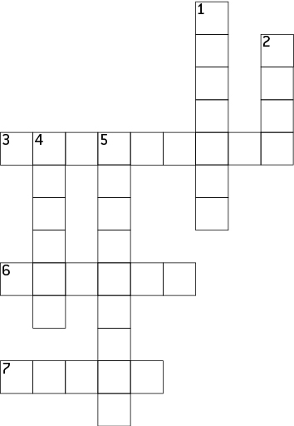

**Across**

3 First element in period four

6 Name of a horizontal row in the periodic table

7 Name of a vertical column in the periodic table

**Down**

1 In group two we need this mineral for our bones

2 Elements have only one type of \_\_\_\_\_\_\_\_\_\_\_.

4 Sixth element in period 2.

5 Used as a cooking foil and number 13

Word detective

3 True or false

Read the statement and circle whether it is true or false.

a ‘Atmos’ means particles that cannot be broken down any further T or F

b The smallest atom in terms of mass is Helium T or F

c Boron (B) and aluminium (Al) are likely to have similar properties T or F

d Nitrogen is a diatomic gas T or F

e An element is an impure substance made up of only one atom T or F

f Artificially made atoms are too small to be stable T or F

Literacy support worksheet

4.7 Atoms bond together to make molecules and compounds

Pages 74–75 and 188

Molecules, compounds and mixtures

Part 1 – Molecules

1 What is the difference between a molecular element and a molecular compound?

2 Name and draw two examples of molecular elements below. An example has been provided for you. (Other molecular elements might include N2 and O2).

|  |  |  |
| --- | --- | --- |
| Hydrogen  SW0445_00951 |  |  |

3 Write and draw two examples of molecular compounds below. An example has been provided for you.

(See p 74 of *Oxford Science 8* *Western Australian Curriculum* for other molecular compounds).

|  |  |  |
| --- | --- | --- |
| Hydrogen peroxide  SW0444_00951 |  |  |

Part 2 – Compounds and mixtures

4 What is a compound?

5 What is a mixture?

6 Name and draw two examples of compounds below (an example has been provided for you).

|  |  |  |
| --- | --- | --- |
| Water  SW0446_00951 |  |  |

7 Draw two examples of mixtures below (an example has been provided for you).

|  |  |  |
| --- | --- | --- |
| SW0451_00951 |  |  |

8 Some compounds are molecules like CO2 and some are polymers. What are polymers?

9 Complete the chart of the different types of substances from your student book and draw examples of the bottom three substances in the boxes provided. (Use diagram 4.39 to help you).

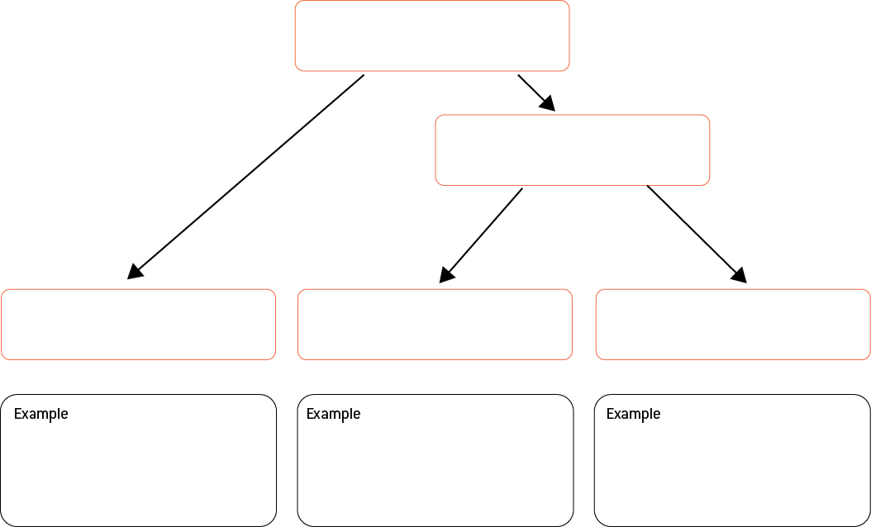

Word detective

10 Matching meaning

Draw a line from the picture to its description

|  |  |
| --- | --- |
| SW0440_00951 | Carbon monoxide – one carbon atom and one oxygen atom (a compound of elements) |
| SW0442_00951 | A mixture with two separate substances (mixture of elements) |
| SW0452_00951 | CO2 (carbon dioxide) – one carbon atom and two oxygen atoms (a compound of elements) |
| SW0447_00951 | O2 – an oxygen molecule with two oxygen atoms (molecule of an element) |
| SW0443_00951 | Unnamed element – a pure substance with only one type of atom (atoms of an element) |